**Task 1: EDA**

**The given dataset consists of the sates and the number of passengers who travelled using “MyWay” cards and paper tickets. The following where the observations made from the given data:**

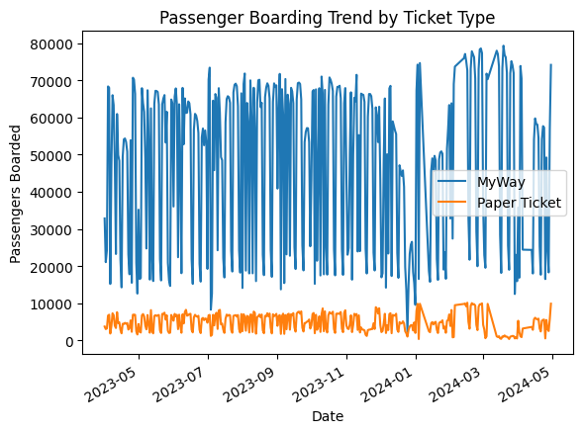

* **In general , the Passengers using the MyWay card are larger in number than the passengers using paper tickets.**

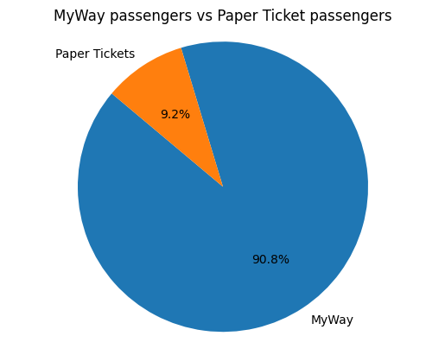

* **Percentage of passengers traveling using MyWay card = 90.77 %**
* **Percentage of passengers traveling using paper ticket = 9.23 %**
* **Number of passengers traveling using MyWay card = 17628676**
* **Number of passengers traveling using paper ticket = 1791675**

**Weekend & Weekday status:**

* **Number of people travelling on weekends = 3619228**
* **Number of people travelling on weekdays = 15801123**

